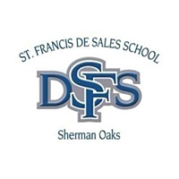
St. Francis De Sales 2018 Harvest Festival / Chili Cook Off
Wine Cellar Donation Form

Family Name: __________________________________________________________________________

Contact Name: _________________________________________________________________________

Phone: __________________________________________________________________________________

Email:____________________________________________________________________________________

Wine Maker or Winery: ___________________________________________________________________

Type: ________________________________________ Year: __________________________

White OR Red OR Rose (Circle One) Value: _______ (Donor’s best estimate of fair market value)
Wine Donation minimum value $25.00
We will be collecting wine at morning drop off at the Kinder and Main gates:
Tuesday, October 2 Thursday, October 4 Tuesday, October 9 Thursday, October 11

Service Hours: 1 hour per $20 dollar bottle of wine with an 5 bottle/hour maximum.
Indicate # of Service Hours: ______ (maximum of 5)
Please note: No wine will be accepted after morning drop off on Thursday, October 11. If wine is dropped off after deadline, it will be donated to the bar and no hours will be given.
Any questions please contact Stephenie Hope at bleuloeil@gmail.com

PLEASE RETURN THIS DONATION WITH WINE DONATION

